**The following instruction for those who don’t have MS Teams application installed.**

1. If You click on the link provided, You will be redirected to the site of the Microsoft platform.
2. Then You will be asked to install Teams on Windows / IOS / Android (depending on the operating system You are using) or use the web application. I recommend installing the application on your computer (option on the left).
3. Then You will be asked to enter your name, which will be used to identify You during the meeting. I recommend that you enter: title / degree First Name Last Name, e.g. prof. John Smith
4. After this step, You will automatically join the team (or the meeting if it is already running) and You can participate in the meeting.
5. If You are not able to join the meeting, You are in the waiting room. Then please wait a while for us to accept Your request to join in.
6. In case of any problems, please contact me. Łukasz Zięba - [l.zieba@uthrad.pl](mailto:l.zieba@uthrad.pl)

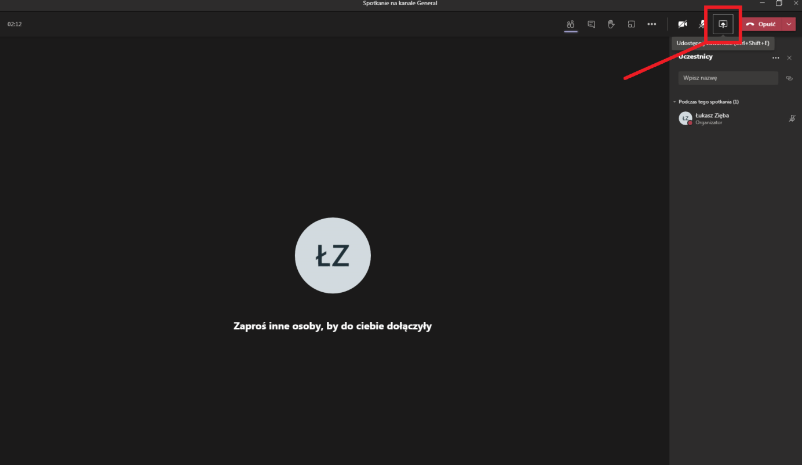

**Pleaseclick on thisicon**

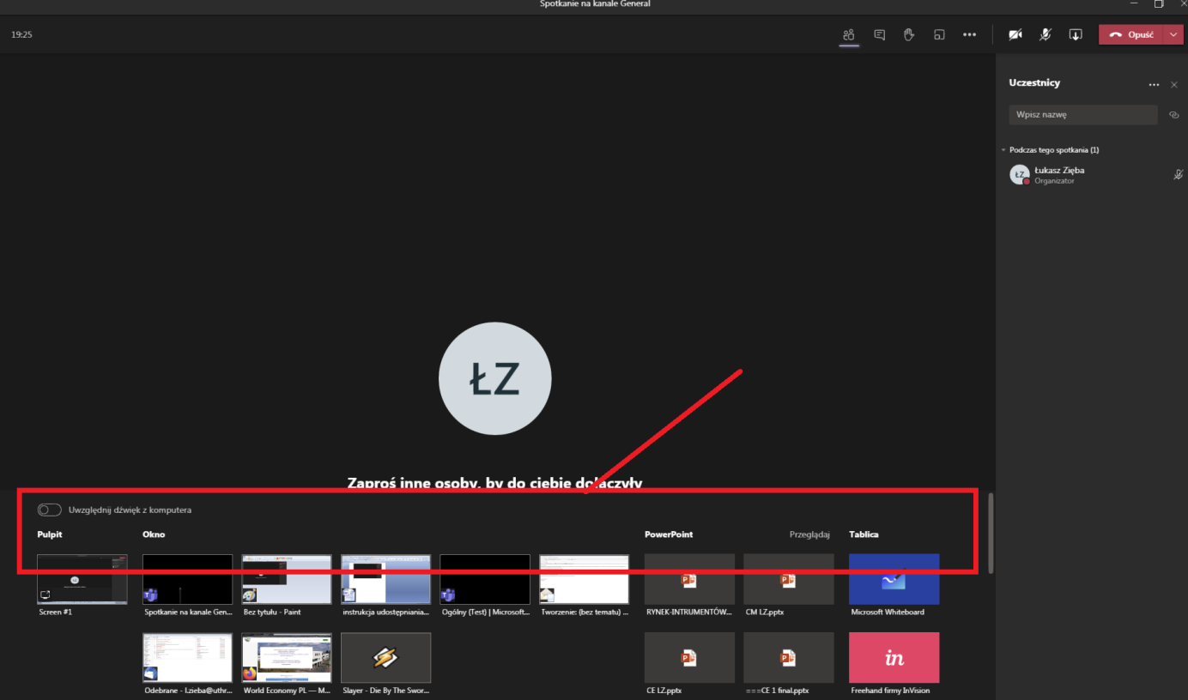

**Options for sharing appear**

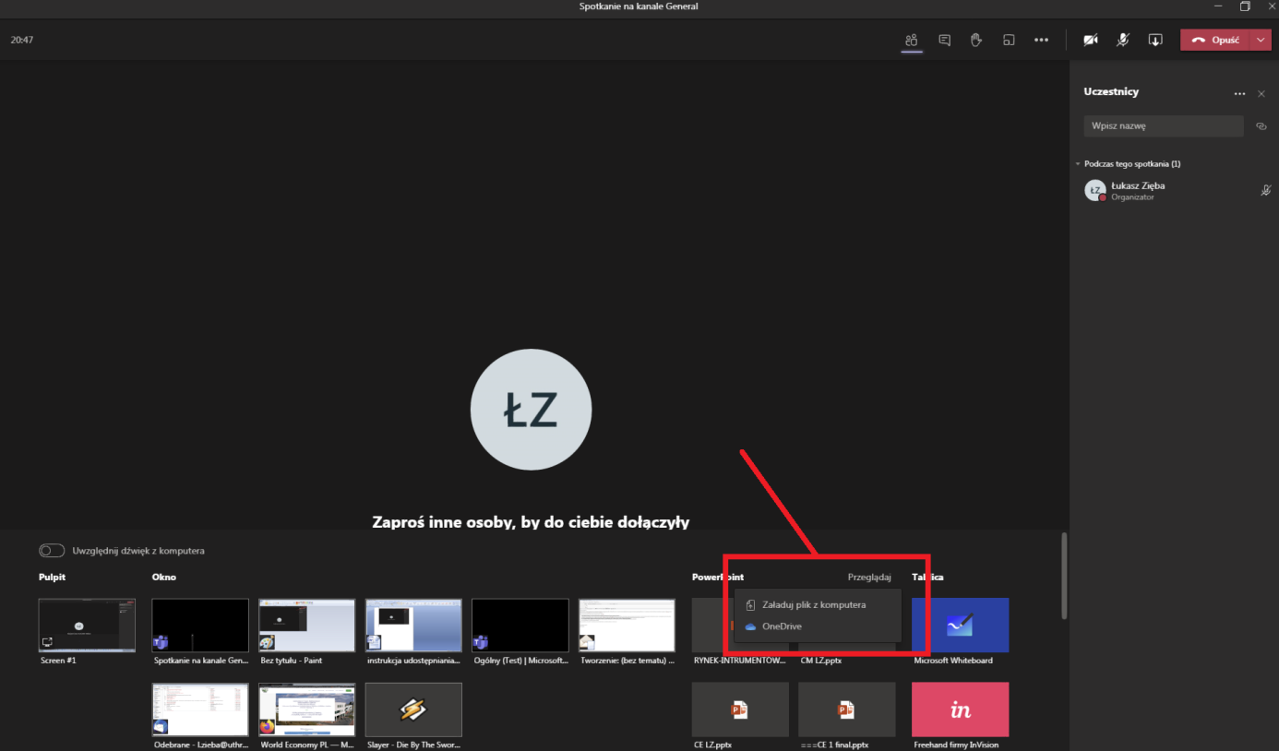

**I recommend choosing this option and loading file from Your computer**

Choosing this way of content sharing ensures the best quality of shared materials.